

**Diko** Backup & Restore Procedures

V1.1



Disclaimer

Copyright 2018-2019 All rights reserved. All concepts, ideas and materials in this document are owned by Speech & Act Education Company Limited. Any reference to partial or all materials in this document without written authorization is strictly prohibited.

For inquiries, please send your email to info@speechnact.asia.

Change History

|  |  |  |  |
| --- | --- | --- | --- |
| **Version** | **Date** | **Sections** | **Remarks** |
| 1.0 | 10th Oct 2018 | All | New document released |
| 1.1 | 30th May 2019 | Chapter 2 Backup & Restore | Updated with details steps of backup and restore, with screen captures |

Table of Contents

1. DIKO Overview 5

2. Backup & Restore 6

2.1 Backup 6

2.1.1 Database Backup 6

2.1.2 File System Backup 6

2.2 Restore 7

2.2.1 Restore Database 7

2.2.2 Restore File System 8

# DIKO Overview

DIKO is a web-based, UNICODE-supported Document Management System. With a web browser, the user can manage and protect the documents within the organization. DIKO offers multi-lingual user interface to serve international users. It can display and accept multi-lingual inputs.

In DIKO, more than 40 document types can be previewed in PDF format and each preview has a watermark with username, IP address and date shown. This is to avoid any potential screen capture of the document content. All document activities are stored in audit trail for future review. Any update on the documents can notify the relevant users via email alert. In addition, DIKO keeps the versions of each document to protect its integrity. Role-based permissions ensure only authorized groups and users can access the documents. Documents stored in DIKO are encrypted so documents can only be viewed within DIKO. SSL is also supported so the data transmission between DIKO and web browser is safe.

Documents can be classified in different categories. Each category consists a group of fields which hold the metadata for searching. DIKO supports both metadata and content search. DIKO allows the users to merge multiple documents to a PDF for printing. Users can share the documents via its share-link to ensure litigate sharing.

With DIKO, all documents are well protected and managed so the corporation is on the safe side in the dynamic business world.

# Backup & Restore

It is very important to backup DIKO on a daily basis to ensure its integrity. In case of disaster happens, the backup can be restored and the operation loss can be minimized.

## 2.1 Backup

DIKO consists of two storage media namely Database and File System. Database stores all document records, audit trails, user groups, etc. File System stores all encrypted files, PDF renditions, full text index, etc. Both storage media should be backed at the same time to ensure data synchronization.

### 2.1.1 Database Backup

You may use some database backup software to backup the DIKO database. Certainly, you may use the SQL Server Management Studio to conduct the backup. The following procedures show you how to use the SQL Server Management Studio to backup the DIKO database installed to its default location

1. 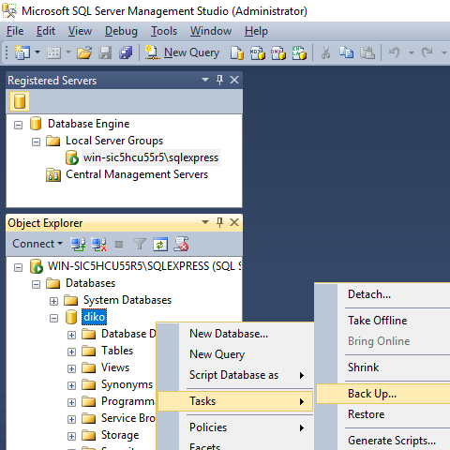In **Object Explorer**, connect to an instance of the SQL Server Database Engine and then expand that instance. Expand **Databases**, right-click at DIKO, point to **Tasks**, and then click **Back Up...**.
2. Then you will see the dialog box below: 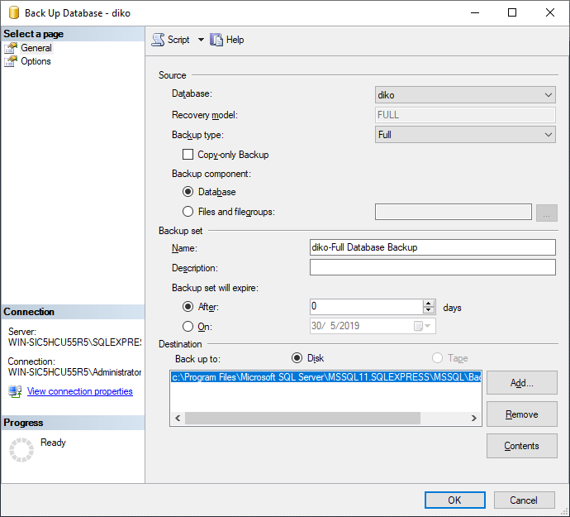
3. Click **OK** to accept the default parameters; You may set the default location for backup to a Network Attached Storage (NAS) for nearline storage. You will see the progress meter at the lower left corner running until backup ended as below:  
   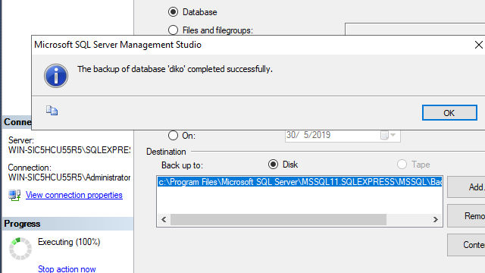

You may use the task scheduler to automate the database backup task.

### 2.1.2 File System Backup

DIKO is by default to be installed on C drive. There is a folder called DIKO which stores the application, file objects and full text index. Therefore, the DIKO folder on C drive should be backup either by using the Copy command or other backup software. You may use a Windows schedule task to conduct the file system backup every night. The backup files are recommended to store on the NAS for protection.

## 2.2 Restore

To restore DIKO is simple, put the database and file system backup from the NAS to the default location (i.e. C drive) and DIKO will be in production again.

### 2.2.1 Restore Database

The following procedures show how to restore the database backup using MS SQL Server Management Studio.

1. In **Object Explorer**, connect to an instance of the SQL Server Database Engine and then expand that instance.
2. Right-click **Databases** and select **Restore Database...**
3. On the **General** page, use the **Source** section to specify the source and location of the backup sets to restore. Select one of the following options:
4. Select the database to restore from the drop-down list. The list contains only databases that have been backed up according to the **msdb** backup history.
5. In the **Destination** section, the **Database** box is automatically populated with the name of the database to be restored. To change the name of the database, enter the new name in the **Database** box.
6. In the **Restore to** box, leave the default as **To the last backup taken** or click on **Timeline** to access the **Backup Timeline** dialog box to manually select a point in time to stop the recovery action. For more information on designating a specific point in time, see [Backup Timeline](https://docs.microsoft.com/en-us/sql/relational-databases/backup-restore/backup-timeline?view=sql-server-2017&lc=1033).
7. In the **Backup sets to restore** grid, select the backups to restore. This grid displays the backups available for the specified location. By default, a recovery plan is suggested. To override the suggested recovery plan, you can change the selections in the grid. Backups that depend on the restoration of an earlier backup are automatically deselected when the earlier backup is deselected.
8. Restore operations may fail if there are active connections to the database. Check the **Close existing connections option** to ensure that all active connections between Management Studio and the database are closed. This check box sets the database to single user mode before performing the restore operations, and sets the database to multi-user mode when complete.
9. Select **Prompt before restoring each backup** if you wish to be prompted between each restore operation. This is not usually necessary unless the database is large and you wish to monitor the status of the restore operation.
10. Click **OK**.

### 2.2.2 Restore File System

To restore the file system, simply copy the whole DIKO folder with its content and put it back on C drive (or DIKO installed hard drive).